
University of Azad Jammu & Kashmir
Department of Software Engineering
MID TERM LAB EXAM
============================================================
Name: | Amish Irshad
Roll Number: | 2024-CET-19
Session: | 2024-2028
Subject: | Graphic Designing
Lab Instructor: | Engr Ahmed Khawaja
Date: | 30-04-2026

Course: Graphic Designing | Semester: Spring-2026 | Class: 4th Semester

QUESTION 1: Promotional Poster for "Design Sprint 2026" Event
A new student society named "Creative Tech Society" has launched in the Department of Software Engineering. The society wants to promote its first event, "Design Sprint 2026", where students will learn basic poster designing, logo designing, and branding skills.
Marks: 5 | CLO: C-3 | BTL: Apply
Design Description:
The poster design incorporates the following principles and elements of graphic design:
• BALANCE: Symmetrical layout with event title centered and visual elements evenly distributed
• CONTRAST: Bright yellow/green background with bold red and white text for high visibility
• EMPHASIS: Large "DESIGN SPRINT" text as the focal point with supporting imagery
• PROXIMITY: Related elements grouped together - event details in one section, visuals in another
• ALIGNMENT: Clean grid-based layout with consistent margins
• REPETITION: Consistent color scheme and font styles throughout
Visual Elements Used:
- Rocket icon symbolizing innovation and launch
- Computer screens showing design work
- Creative illustrations representing graphic design skills
- Bold typography for event title
- Vibrant color palette (yellow, red, white, blue)
The poster effectively communicates the event's purpose: teaching poster design, logo design, and branding skills to students.
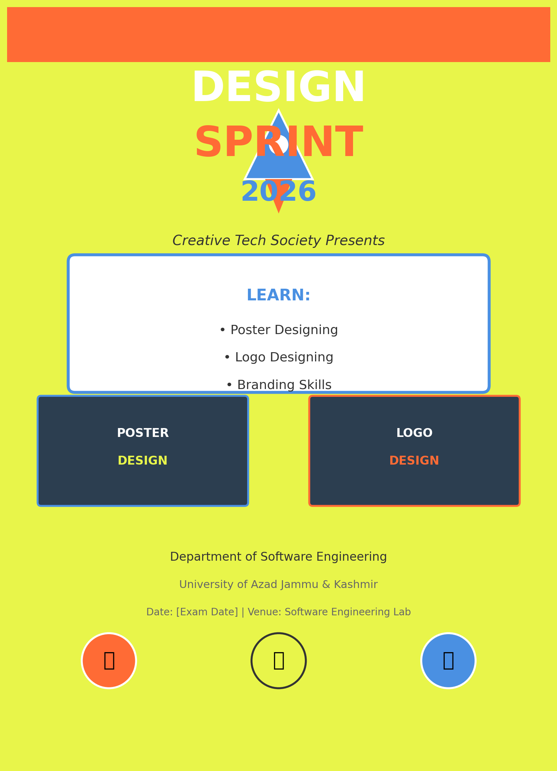
Principle/Element | Application in Design
Line | Clean borders and dividers separating content sections
Shape | Geometric shapes, rocket icon, screen frames
Color | Vibrant yellow background, red accents, white text
Texture | Digital flat design with subtle gradients
Typography | Bold sans-serif fonts for headings, clean body text
Space | Adequate white space around elements for readability

QUESTION 2: Logo Design for "Creative Tech Society"
Design a simple and meaningful logo for "Creative Tech Society." The logo should represent creativity, technology, teamwork, or innovation. It should be suitable for use on posters, certificates, social media pages, and event banners.
Marks: 5 | CLO: C-5 | BTL: Create
Logo Design Description:
The logo for Creative Tech Society is designed to embody the core values of creativity, technology, teamwork, and innovation.
Design Concept:
• SYMBOL: A circular emblem combining human figures (representing teamwork/community) with circuit board patterns (representing technology)
• The interconnected nodes and lines symbolize networking, collaboration, and digital connectivity
• The upward-reaching figures represent growth, aspiration, and creative energy
Color Scheme:
• Deep Blue (#003366): Represents technology, trust, and professionalism
• Bright Orange/Red: Represents creativity, energy, and innovation
• White: Represents clarity and simplicity
Typography:
• Clean, modern sans-serif font for "CREATIVE TECH SOCIETY"
• Bold weight for strong visual impact
• Suitable for both digital and print media
Versatility:
• Works in full color, black & white, and single color
• Scalable from small social media icons to large event banners
• Clear and recognizable at all sizes
• Suitable for posters, certificates, social media, and banners
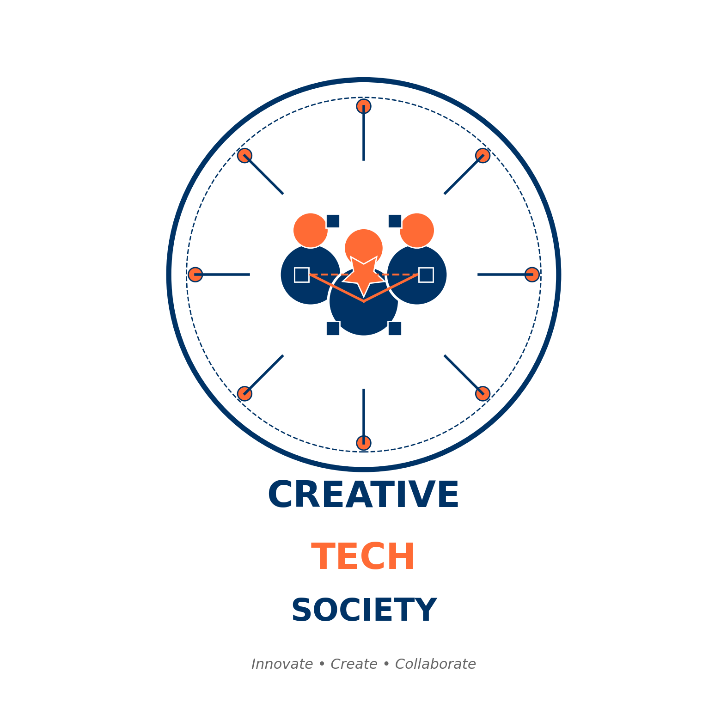
Specification | Details
Design Tool Used | Vector-based design (scalable for all formats)
Primary Colors | Deep Blue, Orange/Red, White
Symbol Meaning | Human figures + Tech circuits = Community + Technology
Font Style | Modern Sans-Serif, Bold weight
Applications | Posters, Certificates, Social Media, Banners, Letterheads

QUESTION 3: Campaign Poster for "Save Energy, Save Future"
A startup named "GreenByte Solutions" is launching an awareness campaign titled "Save Energy, Save Future." The startup wants a poster to promote the campaign.
Marks: 5 | CLO: C-5 | BTL: Create
Campaign Poster Design Description:
The campaign poster for GreenByte Solutions is designed with a professional environmental theme to promote energy conservation awareness.
Design Structure:
• HEADER: "GreenByte Solutions" branding at top with company tagline
• MAIN TITLE: "SAVE ENERGY, SAVE FUTURE" in large bold typography
• VISUAL CENTERPIECE: Earth globe with energy-efficient LED light bulb
• SUPPORTING ELEMENTS: Green leaves, trees, eco-friendly symbols
• CALL TO ACTION: Clear message encouraging energy-saving behavior
• FOOTER: Company contact information and campaign hashtags
Color Scheme (Green/Environmental):
• Forest Green (#228B22): Primary color representing nature and sustainability
• Light Green (#90EE90): Secondary color for highlights and accents
• Earth Brown (#8B4513): For tree trunks and natural elements
• White/Cream: For text readability and clean background
• Sky Blue (#87CEEB): For water and sky elements
Typography:
• Heading: Bold, impactful font for main message
• Body: Clean, readable font for details
• All text is highly readable with proper contrast
Visual Elements Used:
- Earth/Globe: Represents the planet we need to protect
- LED Light Bulb: Symbolizes energy efficiency and modern solutions
- Green Leaves: Natural eco-friendly symbolism
- Trees: Environmental growth and sustainability
- Energy Icons: Lightning bolts, power symbols
- Eco-friendly Symbols: Recycling, renewable energy markers
Layout Features:
- Proper structure with clear visual hierarchy
- Balanced spacing between all elements
- Professional alignment using grid system
- Clear message with readable text at all sizes
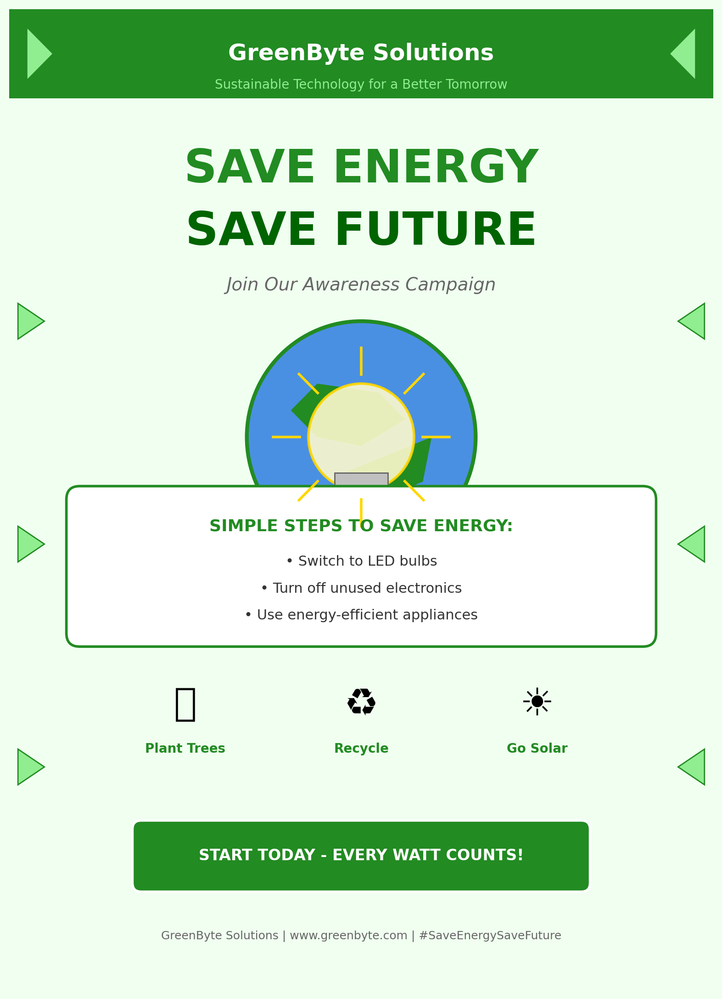
Design Requirement | Implementation
Proper Structure | Header, body, visual center, footer layout
Clear Message | "Save Energy, Save Future" prominently displayed
Readable Text | High contrast, appropriate font sizes, clear hierarchy
Green Color Scheme | Forest green, light green, earth tones throughout
Balanced Spacing | Consistent margins and padding between elements
Professional Alignment | Grid-based layout with centered focal point
Visual Elements | Earth, bulb, leaves, trees, energy icons, eco symbols

DESIGN REFERENCE IMAGES
The following images serve as design references and inspiration for the three questions. These represent the style, layout, and visual approach used in creating the designs.
Reference 1: Design Sprint 2026 Poster Style

Style: Vibrant yellow/green background, bold typography, creative illustrations, modern flat design approach. Features rocket symbolizing innovation and computer screens showing design work.

Reference 2: Creative Tech Society Logo Style

Style: Circular emblem combining human figures (teamwork) with technology circuits. Deep blue and orange color scheme. Modern, scalable vector design suitable for all media.

Reference 3: Save Energy Campaign Poster Style

Style: Environmental poster with green color scheme. Features earth globe, energy-efficient light bulb, trees, and nature elements. Professional layout with clear conservation message.

TOOLS AND SOFTWARE USED
The following tools and software were used to create the designs for this lab examination:
Tool/Software | Purpose | Features Used
Canva / Adobe Express | Poster Design | Templates, shapes, text, color palettes, icons
Adobe Illustrator | Logo Design | Vector shapes, typography, color schemes, export
Adobe Photoshop | Image Editing | Layers, filters, color correction, composition
PowerPoint | Layout Design | Shapes, text boxes, alignment tools, export

GRAPHIC DESIGN PRINCIPLES APPLIED
Summary of graphic design principles and elements applied across all three designs:
• Balance: Symmetrical and asymmetrical balance achieved through careful placement of visual elements
• Contrast: Color contrast, size contrast, and weight contrast used to create visual interest and hierarchy
• Emphasis: Focal points created using size, color, and positioning to draw attention to key messages
• Movement: Visual flow guided through alignment, spacing, and directional elements
• Pattern: Repetition of colors, shapes, and styles to create unity and consistency
• Rhythm: Consistent spacing and sizing creating visual rhythm and harmony
• Unity: All elements working together to create cohesive, professional designs
• Variety: Different elements and styles used to maintain interest while maintaining unity.

